

VITYARTHI PROJECT

Topic:- Personal Finance Manager & Budget Tracker

Submitted by: Umang Patel
Registration No: 25MEI10037
Faculty:- DR. A.V.R. MAYURI
Course Code:- CSE1021
Slot:- A11+A12+A13

INDEX

S.NO | TOPIC | PAGE.NO
1. | Abstract | 3
2. | Problem Statement | 4
3. | System Architecture | 5
4. | Key Features | 6
5. | Implementation Details (Code Logic) | 8
6. | Future Scope | 8
7. | Result | 9-15
8. | Conclusion | 15
9. | References | 16

1. Abstract:-
Financial literacy and management are crucial skills for students and young professionals. However, tracking daily expenses, adhering to budgets, and planning for future savings can be tedious without the right tools. This project, "Personal Finance Manager," is a Python-based application designed to simplify personal financial tracking. It offers a robust Command Line Interface (CLI) for users to record transactions, set dynamic budgets, analyze spending habits through generated reports, and track progress toward specific savings goals. The system utilizes persistent JSON storage to ensure data integrity and availability.

2. Problem Statement:-
In the modern digital economy, small expenses (like UPI payments, subscriptions, and daily commute costs) often accumulate unnoticed, leading to financial strain. The specific problems this project addresses are:
- Lack of Awareness: Individuals often do not know where their money is going due to a lack of centralized tracking.
- Budget Overruns: Without real-time tracking against set limits, it is easy to overspend on non-essential categories like entertainment or dining out.
- Difficulty in Goal Setting: Saving for big purchases (like a laptop or a vacation) is often disorganized, resulting in missed financial targets.
- Complexity of Existing Tools: Many commercial finance apps are cluttered with ads, require internet connectivity, or demand access to sensitive bank credentials, raising privacy concerns.

Solution: This project provides a lightweight, offline, and secure tool that allows the user to manually input data, ensuring they remain conscious of their spending while providing powerful analytics to improve their financial health.

3. System Architecture:-
The system is built using Python and follows an Object-Oriented Programming (OOP) approach. It utilizes a central FinanceManager class to handle all logic and data manipulation.
- Language: Python 3.x
- Data Storage: JSON (JavaScript Object Notation) for lightweight, human-readable, and persistent data storage.
- Libraries Used: json (data handling), datetime (timestamping), os (file management), collections (data grouping).

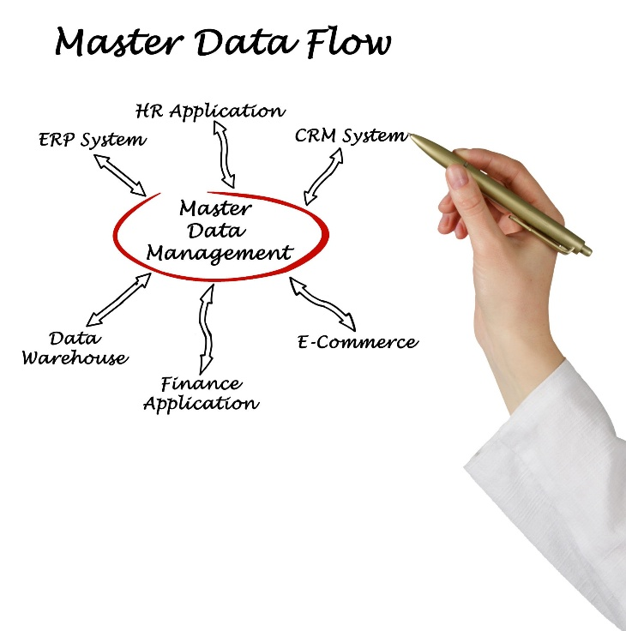

4. Key Features:-
The Personal Finance Manager is equipped with the following core modules:
4.1. Comprehensive Transaction Management
- Income & Expense Logging: Users can record transactions with detailed attributes including Amount, Category, Description, Payment Method, Recurring Status, and Tags.
- Search Functionality: A keyword-based search engine allows users to find specific past transactions by description, category, or tags.
- Filtering: Users can view transaction history filtered by type (Income/Expense) or specific months.
4.2. Smart Budgeting System
- Category-wise Limits: Users can set specific monthly spending limits for different categories (e.g., Food, Transport).
- Visual Progress Bars: The "View Budget Status" feature displays ASCII-based progress bars, providing an immediate visual representation of how much of the budget has been consumed.
- Alert Thresholds: The system includes an intelligent alert mechanism. It warns the user when they cross a specific percentage (default 80%) of their budget and issues a critical alert when the budget is exceeded.

4.3. Savings Goal Tracker
- Goal Setting: Users can define custom savings goals (e.g., "Emergency Fund") with target amounts, deadlines, and priority levels.
- Progress Tracking: The system calculates the percentage saved and visualizes it with progress bars.
- Forecasting: Based on the deadline and remaining amount, the system automatically calculates the "Required Monthly Saving" needed to achieve the goal on time.
4.4. Analytical Reporting
- Monthly Financial Report: Generates a detailed summary including Total Income, Total Expenses, Net Savings, and Savings Rate.
- Category Breakdown: Displays a sorted list of expenses by category with percentage distribution.
- Financial Health Check: Provides automated feedback based on the user's savings rate (e.g., "Excellent," "Moderate," or "Critical").
4.5. Intelligent Insights
The system analyzes historical data to provide actionable insights, such as:
- Trend Analysis: Comparing current spending to the previous month to detect spikes in expenditure.
- Top Spending Category: Identifying where the user spends the most money.
- Recurring Expense Detection: Calculating the total burden of fixed monthly costs (subscriptions, bills).
5. Implementation Details (Code Logic)
- Data Persistence: The load_data() and save_data() methods ensure that the user's financial records are stored in finance_data.json. If the file does not exist, the system initializes with realistic demo data.
- Object-Oriented Design: The FinanceManager class encapsulates all methods, keeping the global namespace clean and the code modular.
- Error Handling: The system uses try-except blocks to handle invalid inputs (e.g., entering text where a number is expected) to prevent crashes.
6. Future Scope:-
To further enhance the project, the following features could be added in the future:
- Graphical User Interface (GUI): Implementing a GUI using Tkinter or PyQt for a more modern look.
- Data Visualization: Integrating matplotlib to generate pie charts and bar graphs for reports.
- Export to CSV/Excel: Allowing users to export their data for use in spreadsheet software.
- Bank SMS Parsing: Automating transaction entry by reading transaction SMS messages (mobile version).
7. RESULT:-
TRANSACTIONS
7.1 User interface
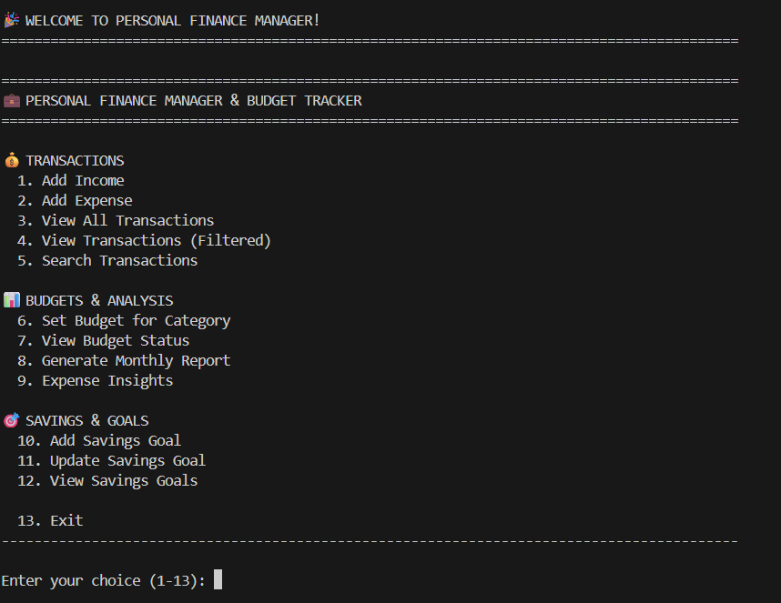

7.2 Add income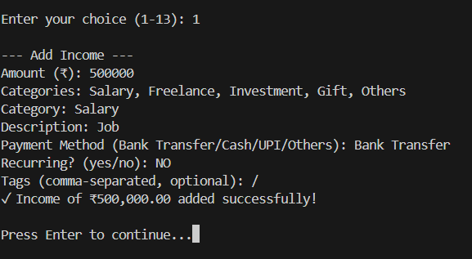
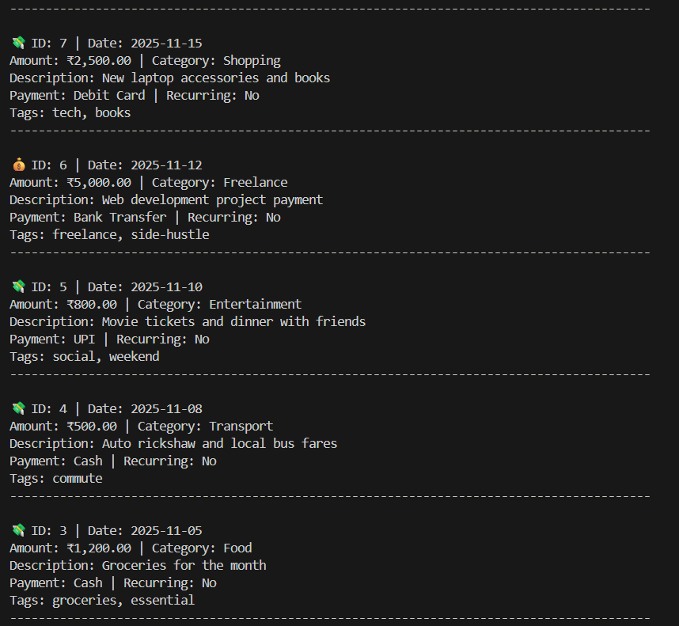
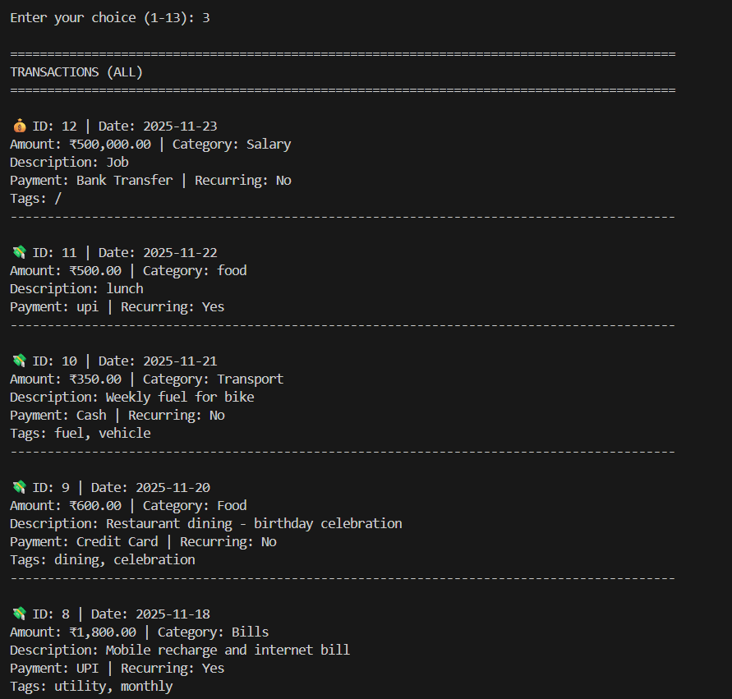
7.3 View all Transaction
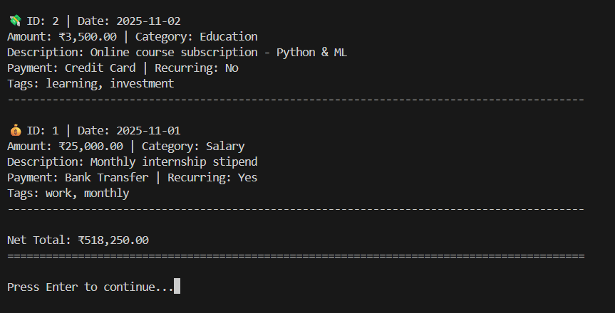
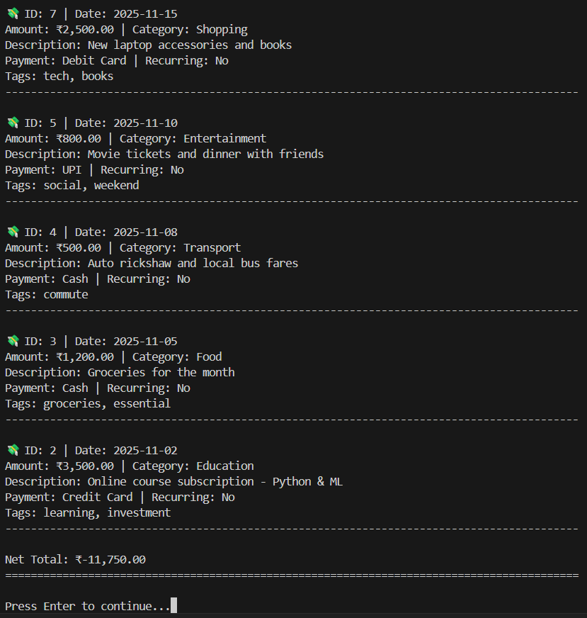
7.4 View Transactions (Filtered)
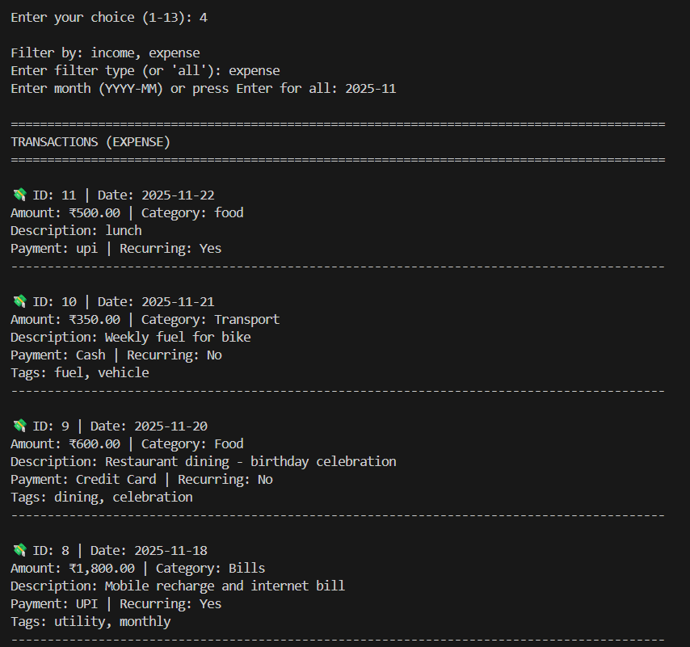
📊 BUDGETS & ANALYSIS
7.5 Set Budget for Category
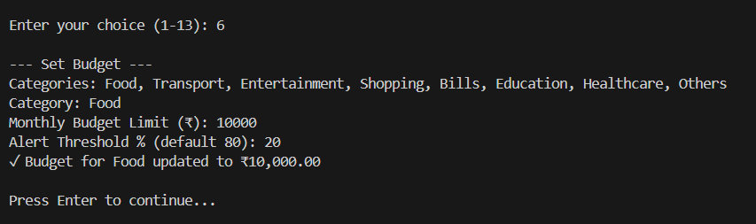

7.6 View Budget Status
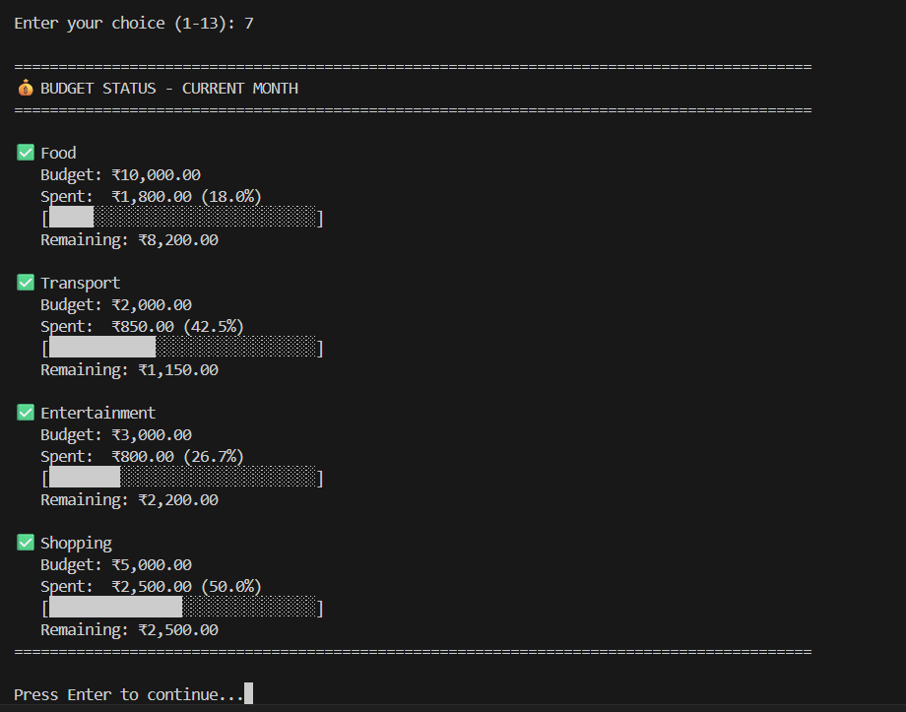
7.7 Generate Monthly Report
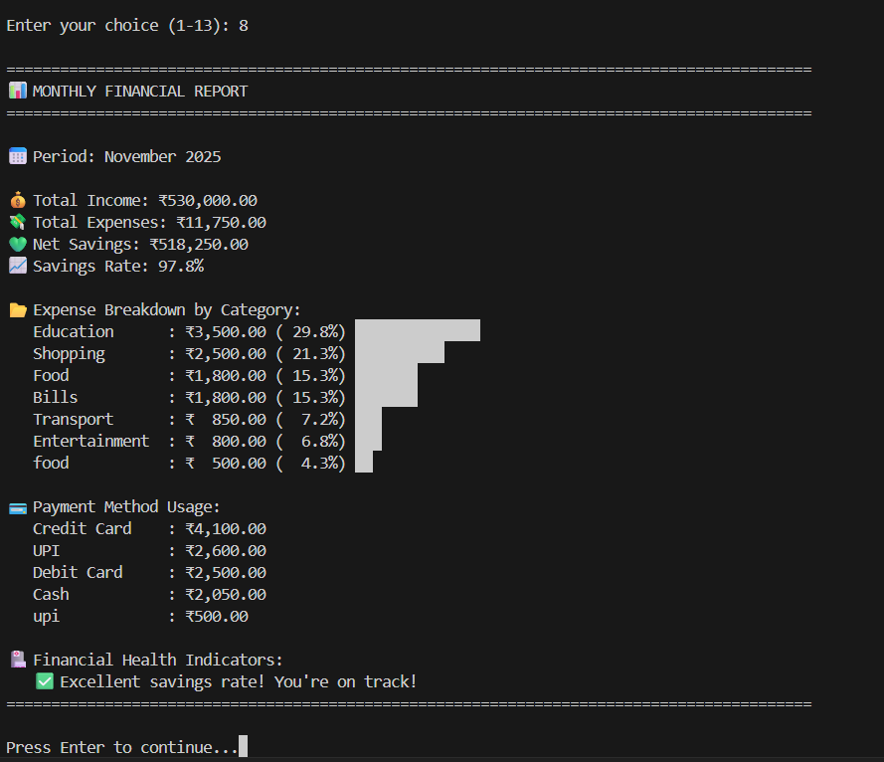

7.8 Expense Insights
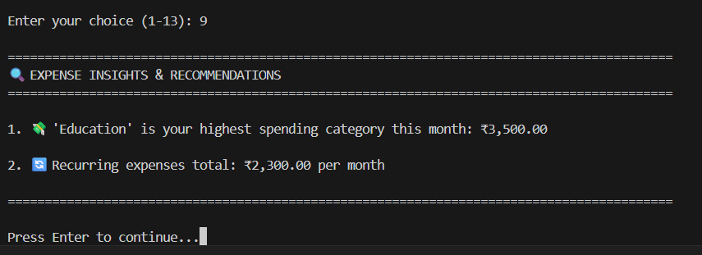

🎯 SAVINGS & GOALS
7.9 Add Savings Goal
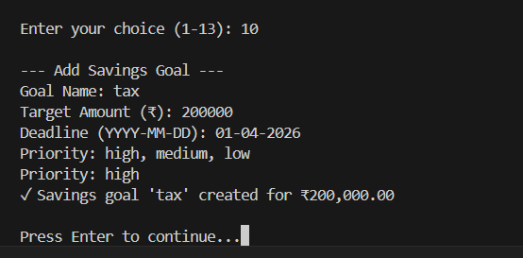

7.10 Savings Goal
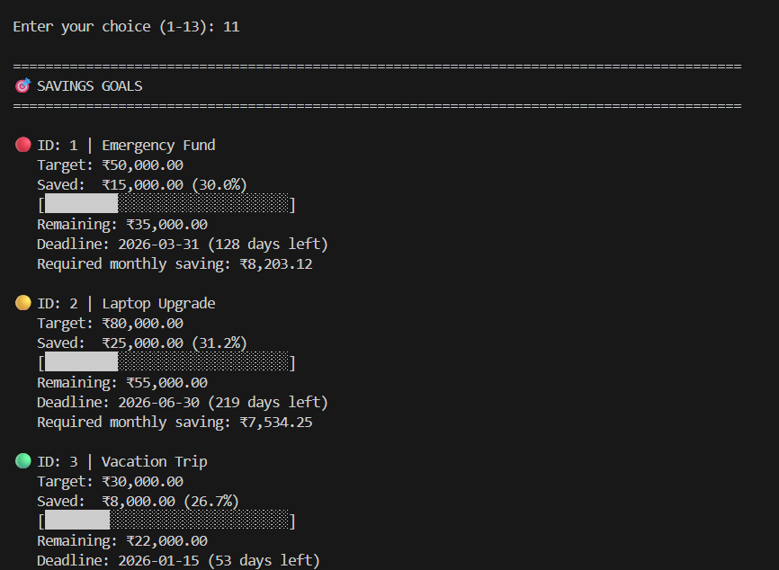

8. Conclusion:-
The Personal Finance Manager successfully addresses the problem of financial disorganization. By combining easy data entry with powerful analytics and budgeting tools, it empowers users to take control of their financial well-being. The project demonstrates the effective use of Python for solving real-world problems through logic, file handling, and data analysis.

9. References:-
Official Documentation:-
- Python Software Foundation. (2025). Python 3.12.0 Documentation. Retrieved from https://docs.python.org/3/
- Python Standard Library. JSON Encoder and Decoder. Retrieved from https://docs.python.org/3/library/json.html
- Python Standard Library. Basic Date and Time Types. Retrieved from https://docs.python.org/3/library/datetime.html
Online Learning Resources:-
GeeksforGeeks. File Handling in Python. Available at:
https://www.geeksforgeeks.org/file-handling-python/
Real Python. Object-Oriented Programming (OOP) in Python 3.
Available at: https://realpython.com/python3-object-oriented-programming/
W3Schools. Python JSON. Available at: https://www.w3schools.com/python/python_json.asp

THANKYOU

